weights = [1.0, 0.5, 1.0]

1 run...

training 1 epoch...

150.52035236358643 seconds used......

1 training finished! average train loss: 0.6129014612455131

evaluating...

Confusion matrix, without normalization

[[ 789 78 155]

[1592 3662 153]

[1353 188 9224]]

Normalized confusion matrix

[[0.77201566 0.07632094 0.15166341]

[0.29443314 0.67727021 0.02829665]

[0.12568509 0.017464 0.85685091]]

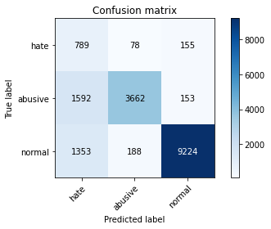

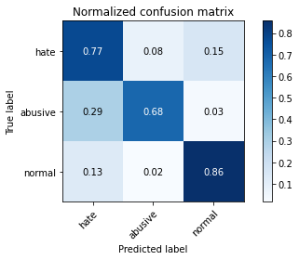

precision recall f1-score support

hate 0.21 0.77 0.33 1022

abusive 0.93 0.68 0.78 5407

normal 0.97 0.86 0.91 10765

accuracy 0.80 17194

macro avg 0.70 0.77 0.68 17194

weighted avg 0.91 0.80 0.84 17194

average eval_loss: 0.49226595601716705, accuracy: 0.7953355821798301

training 2 epoch...

149.95363473892212 seconds used......

2 training finished! average train loss: 0.4437665621882502

evaluating...

Confusion matrix, without normalization

[[ 767 143 112]

[1076 4230 101]

[1722 332 8711]]

Normalized confusion matrix

[[0.75048924 0.13992172 0.10958904]

[0.19900129 0.78231922 0.01867949]

[0.15996284 0.03084069 0.80919647]]

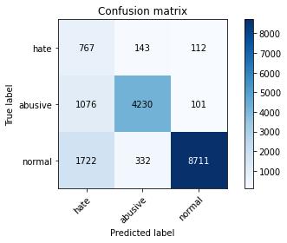

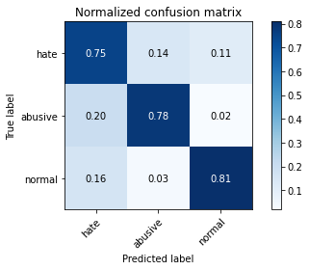

precision recall f1-score support

hate 0.22 0.75 0.33 1022

abusive 0.90 0.78 0.84 5407

normal 0.98 0.81 0.88 10765

accuracy 0.80 17194

macro avg 0.70 0.78 0.69 17194

weighted avg 0.91 0.80 0.84 17194

average eval_loss: 0.5509326022984676, accuracy: 0.7972548563452367

training 3 epoch...

149.9192771911621 seconds used......

3 training finished! average train loss: 0.31704454295522205

evaluating...

Confusion matrix, without normalization

[[ 748 138 136]

[1117 4128 162]

[1531 291 8943]]

Normalized confusion matrix

[[0.73189824 0.13502935 0.13307241]

[0.20658406 0.76345478 0.02996116]

[0.14222016 0.02703205 0.83074779]]

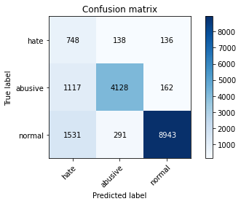

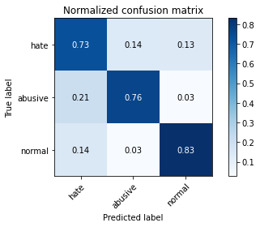

precision recall f1-score support

hate 0.22 0.73 0.34 1022

abusive 0.91 0.76 0.83 5407

normal 0.97 0.83 0.89 10765

accuracy 0.80 17194

macro avg 0.70 0.78 0.69 17194

weighted avg 0.90 0.80 0.84 17194

average eval_loss: 0.6132467786153388, accuracy: 0.803710596719786

training 4 epoch...

149.80706429481506 seconds used......

4 training finished! average train loss: 0.21408632686929294

evaluating...

Confusion matrix, without normalization

[[ 727 148 147]

[1033 4194 180]

[1523 323 8919]]

Normalized confusion matrix

[[0.71135029 0.14481409 0.14383562]

[0.19104864 0.77566118 0.03329018]

[0.14147701 0.03000464 0.82851835]]

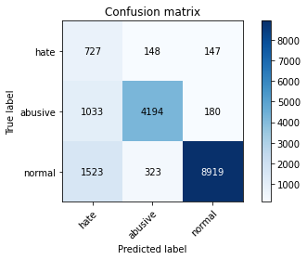

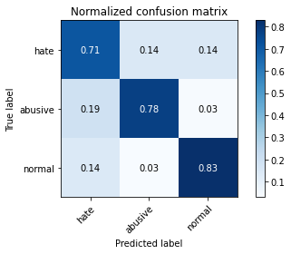

precision recall f1-score support

hate 0.22 0.71 0.34 1022

abusive 0.90 0.78 0.83 5407

normal 0.96 0.83 0.89 10765

accuracy 0.80 17194

macro avg 0.70 0.77 0.69 17194

weighted avg 0.90 0.80 0.84 17194

average eval_loss: 0.6603343090129107, accuracy: 0.8049319530068628

training 5 epoch...

149.88341665267944 seconds used......

5 training finished! average train loss: 0.14119305223033135

evaluating...

Confusion matrix, without normalization

[[ 648 219 155]

[ 764 4477 166]

[1402 335 9028]]

Normalized confusion matrix

[[0.63405088 0.21428571 0.15166341]

[0.14129832 0.82800074 0.03070094]

[0.13023688 0.03111937 0.83864375]]

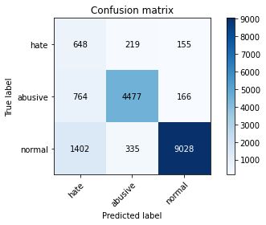

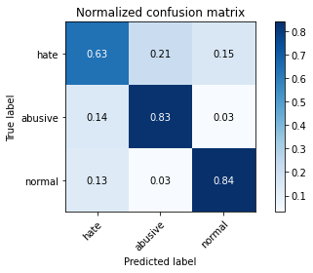

precision recall f1-score support

hate 0.23 0.63 0.34 1022

abusive 0.89 0.83 0.86 5407

normal 0.97 0.84 0.90 10765

accuracy 0.82 17194

macro avg 0.70 0.77 0.70 17194

weighted avg 0.90 0.82 0.85 17194

average eval_loss: 0.6819111060047912, accuracy: 0.8231359776666279

2 run...

training 1 epoch...

149.91001725196838 seconds used......

1 training finished! average train loss: 0.6068324239138286

evaluating...

Confusion matrix, without normalization

[[ 743 128 151]

[1176 4084 147]

[1173 253 9339]]

Normalized confusion matrix

[[0.72700587 0.12524462 0.14774951]

[0.21749584 0.75531718 0.02718698]

[0.10896424 0.02350209 0.86753367]]

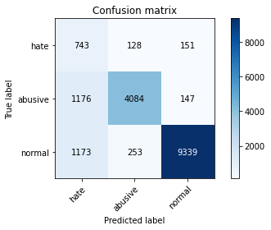

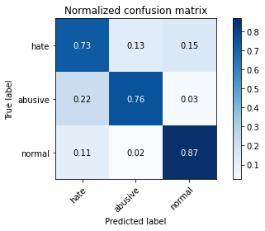

precision recall f1-score support

hate 0.24 0.73 0.36 1022

abusive 0.91 0.76 0.83 5407

normal 0.97 0.87 0.92 10765

accuracy 0.82 17194

macro avg 0.71 0.78 0.70 17194

weighted avg 0.91 0.82 0.85 17194

average eval_loss: 0.47896037829476734, accuracy: 0.8238920553681517

training 2 epoch...

149.9252893924713 seconds used......

2 training finished! average train loss: 0.4365572897427238

evaluating...

Confusion matrix, without normalization

[[ 741 137 144]

[1157 4106 144]

[1329 239 9197]]

Normalized confusion matrix

[[0.72504892 0.13405088 0.1409002 ]

[0.21398188 0.75938598 0.02663214]

[0.12345564 0.02220158 0.85434278]]

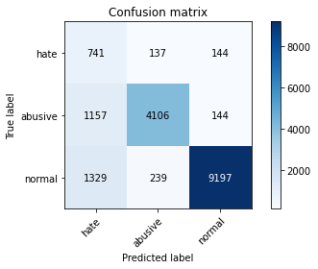

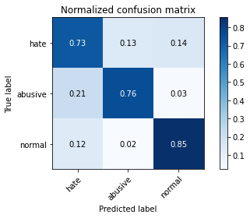

precision recall f1-score support

hate 0.23 0.73 0.35 1022

abusive 0.92 0.76 0.83 5407

normal 0.97 0.85 0.91 10765

accuracy 0.82 17194

macro avg 0.71 0.78 0.70 17194

weighted avg 0.91 0.82 0.85 17194

average eval_loss: 0.45275127781165203, accuracy: 0.8167965569384669

training 3 epoch...

149.96112895011902 seconds used......

3 training finished! average train loss: 0.31743755598571444

evaluating...

Confusion matrix, without normalization

[[ 767 111 144]

[1481 3767 159]

[1507 216 9042]]

Normalized confusion matrix

[[0.75048924 0.10861057 0.1409002 ]

[0.2739042 0.69668948 0.02940633]

[0.13999071 0.02006503 0.83994426]]

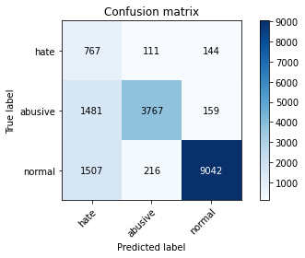

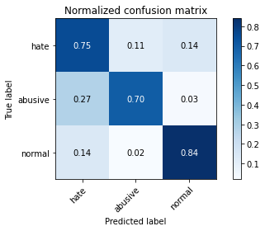

precision recall f1-score support

hate 0.20 0.75 0.32 1022

abusive 0.92 0.70 0.79 5407

normal 0.97 0.84 0.90 10765

accuracy 0.79 17194

macro avg 0.70 0.76 0.67 17194

weighted avg 0.91 0.79 0.83 17194

average eval_loss: 0.5956785999455078, accuracy: 0.7895777596836105

training 4 epoch...

150.0245440006256 seconds used......

4 training finished! average train loss: 0.20448144162851586

evaluating...

Confusion matrix, without normalization

[[ 757 129 136]

[1409 3834 164]

[1573 219 8973]]

Normalized confusion matrix

[[0.7407045 0.12622309 0.13307241]

[0.26058813 0.70908082 0.03033105]

[0.14612169 0.02034371 0.8335346 ]]

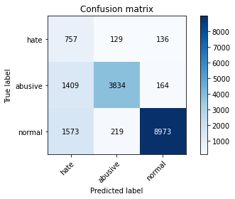

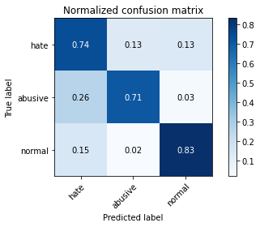

precision recall f1-score support

hate 0.20 0.74 0.32 1022

abusive 0.92 0.71 0.80 5407

normal 0.97 0.83 0.90 10765

accuracy 0.79 17194

macro avg 0.70 0.76 0.67 17194

weighted avg 0.91 0.79 0.83 17194

average eval_loss: 0.6976176623211697, accuracy: 0.7888798418052809

training 5 epoch...

150.25831270217896 seconds used......

5 training finished! average train loss: 0.14523768093874237

evaluating...

Confusion matrix, without normalization

[[ 691 193 138]

[1017 4262 128]

[1714 446 8605]]

Normalized confusion matrix

[[0.67612524 0.1888454 0.13502935]

[0.18808951 0.78823747 0.02367302]

[0.15921969 0.04143056 0.79934974]]

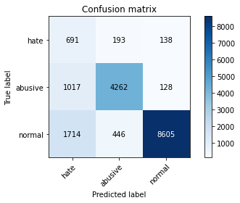

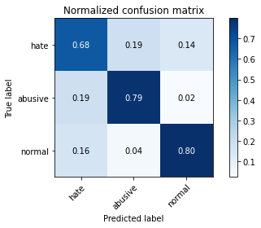

precision recall f1-score support

hate 0.20 0.68 0.31 1022

abusive 0.87 0.79 0.83 5407

normal 0.97 0.80 0.88 10765

accuracy 0.79 17194

macro avg 0.68 0.75 0.67 17194

weighted avg 0.89 0.79 0.83 17194

average eval_loss: 0.7312768049278232, accuracy: 0.7885308828661161

3 run...

training 1 epoch...

150.15611505508423 seconds used......

1 training finished! average train loss: 0.6047085883856896

evaluating...

Confusion matrix, without normalization

[[ 695 138 189]

[1093 4137 177]

[ 941 228 9596]]

Normalized confusion matrix

[[0.68003914 0.13502935 0.18493151]

[0.20214537 0.76511929 0.03273534]

[0.08741291 0.02117975 0.89140734]]

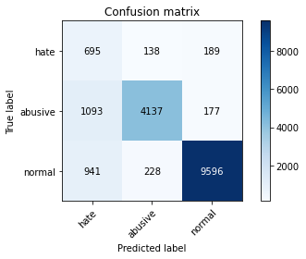

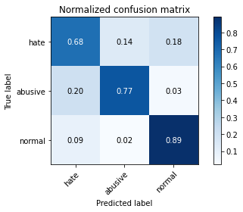

precision recall f1-score support

hate 0.25 0.68 0.37 1022

abusive 0.92 0.77 0.83 5407

normal 0.96 0.89 0.93 10765

accuracy 0.84 17194

macro avg 0.71 0.78 0.71 17194

weighted avg 0.91 0.84 0.86 17194

average eval_loss: 0.4254344757213149, accuracy: 0.8391299290450157

training 2 epoch...

150.05955004692078 seconds used......

2 training finished! average train loss: 0.43789578999474676

evaluating...

Confusion matrix, without normalization

[[ 714 156 152]

[ 995 4267 145]

[1150 304 9311]]

Normalized confusion matrix

[[0.69863014 0.15264188 0.14872798]

[0.18402071 0.7891622 0.02681709]

[0.10682768 0.02823967 0.86493265]]

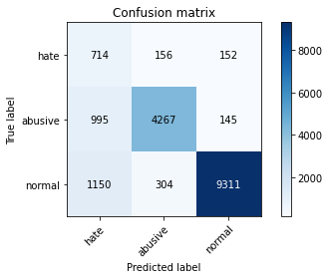

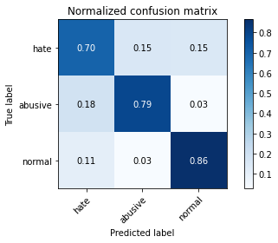

precision recall f1-score support

hate 0.25 0.70 0.37 1022

abusive 0.90 0.79 0.84 5407

normal 0.97 0.86 0.91 10765

accuracy 0.83 17194

macro avg 0.71 0.78 0.71 17194

weighted avg 0.91 0.83 0.86 17194

average eval_loss: 0.4288223150597755, accuracy: 0.831220193090613

training 3 epoch...

150.09650468826294 seconds used......

3 training finished! average train loss: 0.31023810679013114

evaluating...

Confusion matrix, without normalization

[[ 786 117 119]

[1320 3956 131]

[1904 251 8610]]

Normalized confusion matrix

[[0.76908023 0.11448141 0.11643836]

[0.24412798 0.73164416 0.02422785]

[0.17686948 0.0233163 0.79981421]]

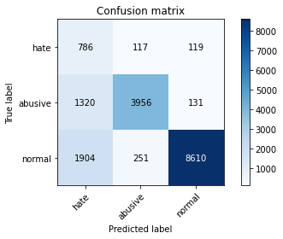

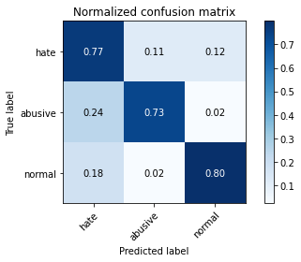

precision recall f1-score support

hate 0.20 0.77 0.31 1022

abusive 0.91 0.73 0.81 5407

normal 0.97 0.80 0.88 10765

accuracy 0.78 17194

macro avg 0.69 0.77 0.67 17194

weighted avg 0.91 0.78 0.82 17194

average eval_loss: 0.6533044206368369, accuracy: 0.7765499592881238

training 4 epoch...

149.99753761291504 seconds used......

4 training finished! average train loss: 0.20556529512961078

evaluating...

Confusion matrix, without normalization

[[ 722 130 170]

[1330 3889 188]

[1292 221 9252]]

Normalized confusion matrix

[[0.70645793 0.12720157 0.16634051]

[0.24597744 0.71925282 0.03476974]

[0.12001858 0.02052949 0.85945193]]

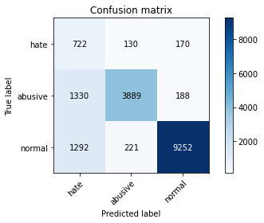

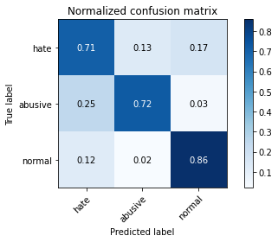

precision recall f1-score support

hate 0.22 0.71 0.33 1022

abusive 0.92 0.72 0.81 5407

normal 0.96 0.86 0.91 10765

accuracy 0.81 17194

macro avg 0.70 0.76 0.68 17194

weighted avg 0.90 0.81 0.84 17194

average eval_loss: 0.5821513501104227, accuracy: 0.806269628940328

training 5 epoch...

150.128324508667 seconds used......

5 training finished! average train loss: 0.14048498342734494

evaluating...

Confusion matrix, without normalization

[[ 703 148 171]

[1285 3906 216]

[1251 244 9270]]

Normalized confusion matrix

[[0.68786693 0.14481409 0.16731898]

[0.23765489 0.72239689 0.03994822]

[0.11620994 0.02266605 0.86112401]]

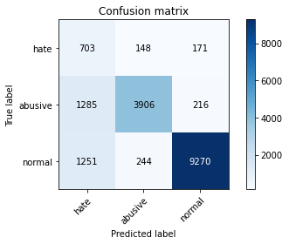

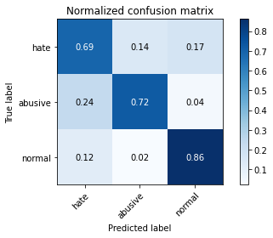

precision recall f1-score support

hate 0.22 0.69 0.33 1022

abusive 0.91 0.72 0.80 5407

normal 0.96 0.86 0.91 10765

accuracy 0.81 17194

macro avg 0.70 0.76 0.68 17194

weighted avg 0.90 0.81 0.84 17194

average eval_loss: 0.7158470818957011, accuracy: 0.8072001861114342

4 run...

training 1 epoch...

149.9046950340271 seconds used......

1 training finished! average train loss: 0.5914935785141809

evaluating...

Confusion matrix, without normalization

[[ 705 144 173]

[1009 4234 164]

[ 954 271 9540]]

Normalized confusion matrix

[[0.68982387 0.1409002 0.16927593]

[0.18660995 0.783059 0.03033105]

[0.08862053 0.02517418 0.88620529]]

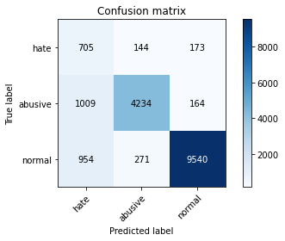

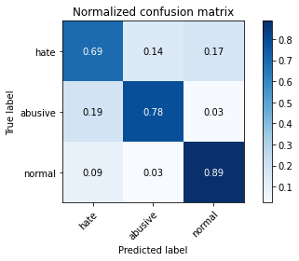

precision recall f1-score support

hate 0.26 0.69 0.38 1022

abusive 0.91 0.78 0.84 5407

normal 0.97 0.89 0.92 10765

accuracy 0.84 17194

macro avg 0.71 0.79 0.72 17194

weighted avg 0.91 0.84 0.87 17194

average eval_loss: 0.429579485225123, accuracy: 0.8420960800279167

training 2 epoch...

150.00143718719482 seconds used......

2 training finished! average train loss: 0.4311306150987509

evaluating...

Confusion matrix, without normalization

[[ 669 204 149]

[ 685 4553 169]

[1001 359 9405]]

Normalized confusion matrix

[[0.65459883 0.19960861 0.14579256]

[0.12668763 0.84205659 0.03125578]

[0.09298653 0.03334882 0.87366465]]

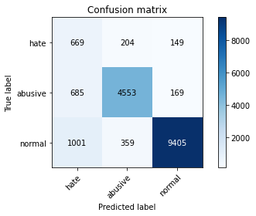

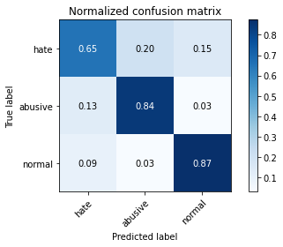

precision recall f1-score support

hate 0.28 0.65 0.40 1022

abusive 0.89 0.84 0.87 5407

normal 0.97 0.87 0.92 10765

accuracy 0.85 17194

macro avg 0.71 0.79 0.73 17194

weighted avg 0.90 0.85 0.87 17194

average eval_loss: 0.4229669490785793, accuracy: 0.850703733860649

training 3 epoch...

150.10382676124573 seconds used......

3 training finished! average train loss: 0.30966964865242114

evaluating...

Confusion matrix, without normalization

[[ 760 159 103]

[1113 4187 107]

[1910 290 8565]]

Normalized confusion matrix

[[0.74363992 0.1555773 0.10078278]

[0.20584428 0.77436656 0.01978916]

[0.17742685 0.02693915 0.795634 ]]

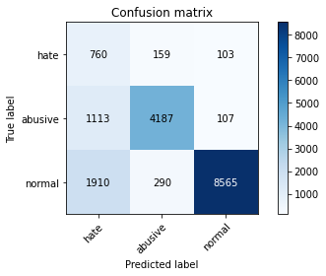

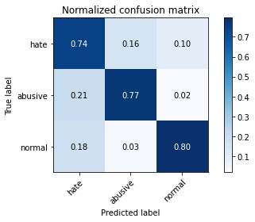

precision recall f1-score support

hate 0.20 0.74 0.32 1022

abusive 0.90 0.77 0.83 5407

normal 0.98 0.80 0.88 10765

accuracy 0.79 17194

macro avg 0.69 0.77 0.68 17194

weighted avg 0.91 0.79 0.83 17194

average eval_loss: 0.668515680955593, accuracy: 0.7858555309991858

training 4 epoch...

150.00270676612854 seconds used......

4 training finished! average train loss: 0.20437074127621763

evaluating...

Confusion matrix, without normalization

[[ 701 174 147]

[ 983 4267 157]

[1385 349 9031]]

Normalized confusion matrix

[[0.68590998 0.1702544 0.14383562]

[0.18180137 0.7891622 0.02903643]

[0.12865769 0.03241988 0.83892243]]

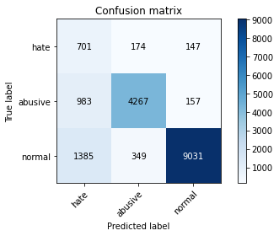

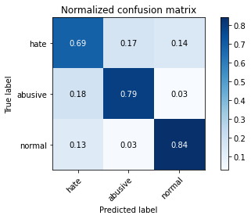

precision recall f1-score support

hate 0.23 0.69 0.34 1022

abusive 0.89 0.79 0.84 5407

normal 0.97 0.84 0.90 10765

accuracy 0.81 17194

macro avg 0.70 0.77 0.69 17194

weighted avg 0.90 0.81 0.85 17194

average eval_loss: 0.6739919353969569, accuracy: 0.8141793648947308

training 5 epoch...

150.08010125160217 seconds used......

5 training finished! average train loss: 0.14096429835769514

evaluating...

Confusion matrix, without normalization

[[ 748 122 152]

[1419 3825 163]

[1490 293 8982]]

Normalized confusion matrix

[[0.73189824 0.11937378 0.14872798]

[0.26243758 0.70741631 0.03014611]

[0.13841152 0.02721784 0.83437065]]

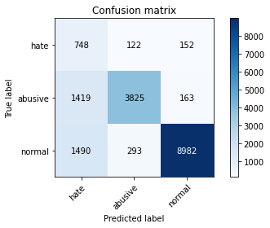

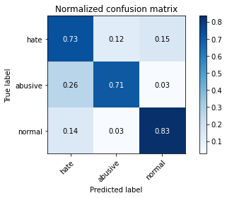

precision recall f1-score support

hate 0.20 0.73 0.32 1022

abusive 0.90 0.71 0.79 5407

normal 0.97 0.83 0.90 10765

accuracy 0.79 17194

macro avg 0.69 0.76 0.67 17194

weighted avg 0.90 0.79 0.83 17194

average eval_loss: 0.7568110932823444, accuracy: 0.7883564033965337

5 run...

training 1 epoch...

150.06815910339355 seconds used......

1 training finished! average train loss: 0.6090211722974583

evaluating...

Confusion matrix, without normalization

[[ 710 180 132]

[ 815 4442 150]

[1458 278 9029]]

Normalized confusion matrix

[[0.69471624 0.17612524 0.12915851]

[0.15073053 0.82152765 0.02774182]

[0.13543892 0.02582443 0.83873665]]

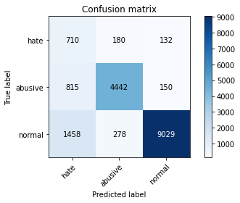

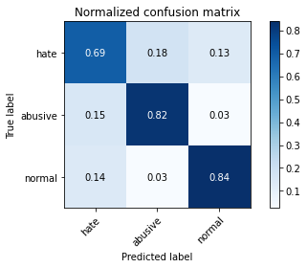

precision recall f1-score support

hate 0.24 0.69 0.35 1022

abusive 0.91 0.82 0.86 5407

normal 0.97 0.84 0.90 10765

accuracy 0.82 17194

macro avg 0.70 0.78 0.71 17194

weighted avg 0.91 0.82 0.86 17194

average eval_loss: 0.4859406549396903, accuracy: 0.8247644527160637

training 2 epoch...

150.17108702659607 seconds used......

2 training finished! average train loss: 0.4347330877897971

evaluating...

Confusion matrix, without normalization

[[ 730 151 141]

[1030 4223 154]

[1332 258 9175]]

Normalized confusion matrix

[[0.71428571 0.14774951 0.13796477]

[0.1904938 0.7810246 0.0284816 ]

[0.12373432 0.02396656 0.85229912]]

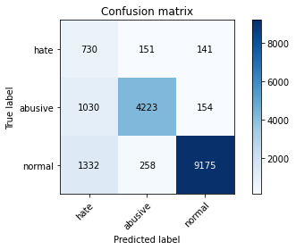

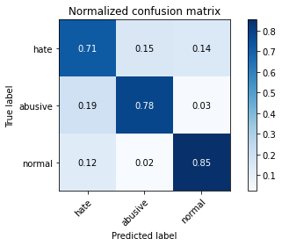

precision recall f1-score support

hate 0.24 0.71 0.35 1022

abusive 0.91 0.78 0.84 5407

normal 0.97 0.85 0.91 10765

accuracy 0.82 17194

macro avg 0.71 0.78 0.70 17194

weighted avg 0.91 0.82 0.85 17194

average eval_loss: 0.4716146748859522, accuracy: 0.8216819820867745

training 3 epoch...

150.03631329536438 seconds used......

3 training finished! average train loss: 0.313408525496654

evaluating...

Confusion matrix, without normalization

[[ 750 116 156]

[1328 3916 163]

[1142 271 9352]]

Normalized confusion matrix

[[0.73385519 0.11350294 0.15264188]

[0.24560755 0.72424635 0.03014611]

[0.10608453 0.02517418 0.86874129]]

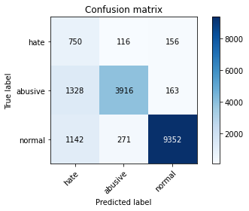

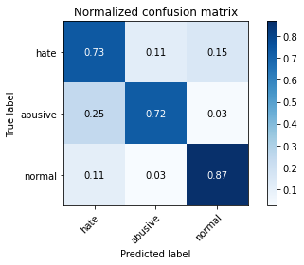

precision recall f1-score support

hate 0.23 0.73 0.35 1022

abusive 0.91 0.72 0.81 5407

normal 0.97 0.87 0.92 10765

accuracy 0.82 17194

macro avg 0.70 0.78 0.69 17194

weighted avg 0.91 0.82 0.85 17194

average eval_loss: 0.5156084831717402, accuracy: 0.8152844015354194

training 4 epoch...

149.9885754585266 seconds used......

4 training finished! average train loss: 0.2049625811396213

evaluating...

Confusion matrix, without normalization

[[ 727 143 152]

[1263 3969 175]

[1531 261 8973]]

Normalized confusion matrix

[[0.71135029 0.13992172 0.14872798]

[0.23358609 0.73404846 0.03236545]

[0.14222016 0.02424524 0.8335346 ]]

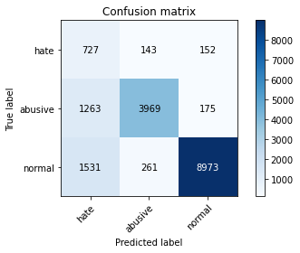

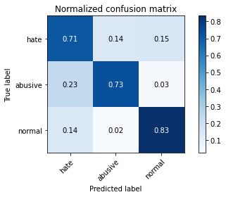

precision recall f1-score support

hate 0.21 0.71 0.32 1022

abusive 0.91 0.73 0.81 5407

normal 0.96 0.83 0.89 10765

accuracy 0.79 17194

macro avg 0.69 0.76 0.68 17194

weighted avg 0.90 0.79 0.83 17194

average eval_loss: 0.666289404725526, accuracy: 0.7949866232406654

training 5 epoch...

150.1389970779419 seconds used......

5 training finished! average train loss: 0.1382119860846978

evaluating...

Confusion matrix, without normalization

[[ 689 169 164]

[1077 4099 231]

[1120 348 9297]]

Normalized confusion matrix

[[0.6741683 0.16536204 0.16046967]

[0.19918624 0.75809136 0.0427224 ]

[0.10404087 0.03232699 0.86363214]]

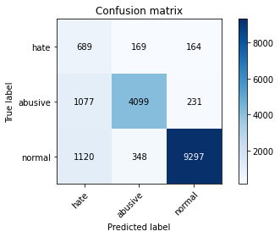

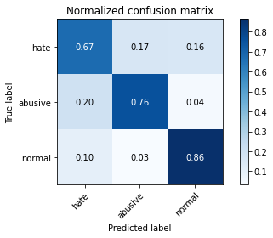

precision recall f1-score support

hate 0.24 0.67 0.35 1022

abusive 0.89 0.76 0.82 5407

normal 0.96 0.86 0.91 10765

accuracy 0.82 17194

macro avg 0.70 0.77 0.69 17194

weighted avg 0.89 0.82 0.85 17194

average eval_loss: 0.6212351202163412, accuracy: 0.8191811096894266